5.6 Economic Growth AP QB
- An increase in which of the following is most likely to increase the long-run growth rate of an economy's real per capita income?
- Population growth
- The proportion of gross domestic product consumed
- The educational attainment of the population
- The supply of money in circulation
- Personal income taxes
- Increases in human capital can be achieved by which of the following?
- Building more factories
- Reducing immigration of skilled workers
- Improving the quality of job-training programs
- Increasing the physical capital per worker
- Increasing government spending on infrastructure
- Which of the following will most likely cause an increase in real output in the long run?
- A decrease in the labor force participation rate
- An increase in the velocity of money
- An open-market sale of government bonds by the central bank
- An increase in immigration from abroad
- An increase in the price level
- Country A’s growth rate in per capita real gross domestic product (GDP) has been consistently higher than that of Country B. Which of the following factors can account for these differences in the per capita GDP growth rates?
- Country B’s government gives more investment tax credits.
- The labor force of Country A is becoming more skilled than the labor force of Country B.
- The natural rate of unemployment is higher in Country A.
- Country A’s central bank is less effective at controlling the inflation rate.
- Although the populations of Countries A and B are the same, Country A has twice as many people who are retired.
- Economic growth is best defined as
- a reduction in the infant mortality rate
- a decrease in the unemployment rate
- an increase in the labor force participation rate
- a short-run increase in gross domestic product without inflation
- a sustained increase in real gross domestic product per capita
- Human capital refers to which of the following?
- The skills and knowledge that enable a worker to be productive
- Machinery used by workers in production
- The accumulated financial wealth of households
- Physical capital owned by households rather than businesses
- Activities that lead to the substitution of physical capital for labor
- Which of the following best describes human capital?
- The number of workers in the labor force
- The physical capital used by workers
- The financial assets owned by workers
- The training and education of workers
- The spending by business for worker recruitment
- Which of the following causes economic growth?
- A decrease in the money supply
- A decrease in the price level
- An increase in nominal output
- An increase in consumption spending
- An increase in labor productivity
- All of the following may result in increases in real gross domestic product in the long run EXCEPT
- technical progress
- investment in human capital
- discovery of new natural resources
- decrease in corporate taxes
- decrease in factor productivity
- Economic growth is shown by a rightward shift in
- the aggregate demand curve
- the long-run Phillips curve
- the production possibilities curve
- the short-run aggregate supply curve
- the money supply curve
- For a given population and a given quantity of labor employed, what will happen to aggregate production and income per capita if there is an increase in a nation’s capital stock?
- Aggregate production will increase, and income per capita will decrease.
- Aggregate production will increase, and income per capita will increase.
- Aggregate production will decrease, and income per capita will be indeterminate.
- Aggregate production will decrease, and income per capita will increase.
- Aggregate production will decrease, and income per capita will be indeterminate.
- In the aggregate demand-aggregate supply model, economic growth can best be represented by a
- leftward shift of the long-run aggregate supply curve
- rightward shift of the long-run aggregate supply curve
- rightward shift of the short-run aggregate supply curve
- rightward shift of the aggregate demand curve
- leftward shift of the aggregate demand curve
- Which of the following will most likely contribute to long-run economic growth?
- High levels of household spending
- High levels of government spending
- High levels of investment in plant and equipment
- Low levels of immigration to the country
- Low levels of foreign investment in the country

FR
- A country is at full employment and produces two types of goods: consumer goods and capital goods.
a. Draw a correctly labeled graph of the production possibilities curve, with consumer goods on the horizontal axis and capital goods on the vertical axis. Indicate a point on your graph, labeled X, that represents full employment and a possible combination in which both goods are being produced.
b. Assume there is an increase in the country’s national savings. Draw a correctly labeled graph of the loanable funds market, showing the change in the real interest rate from the increase in savings.
c. On the same graph from part (a), show another point, labeled Z, that represents full employment and a new combination of consumer goods and capital goods consistent with the increase in the country’s national savings.
d. Referring to your answer to part (c), will the long-run aggregate supply curve shift to the right, shift to the left, or remain the same? Explain.

- The tables below show data for two island nations, Eastland and Southland.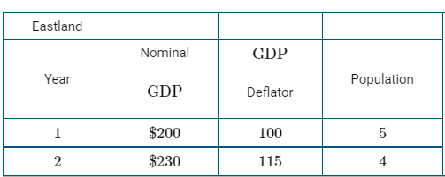 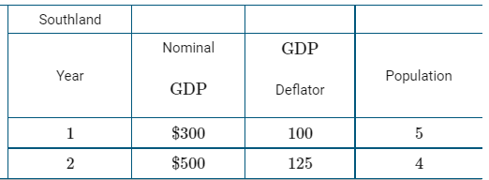
(a) Calculate each of the following for Year 2. Show your work.(i) Real GDP per capita for Eastland(ii) Real GDP per capita for Southland
(b) If Eastland and Southland have the same velocity of money in Year 2, which nation must have the higher money supply in Year 2 ? Explain.
(c) Calculate each of the following in Year 2. Show your work.(i) The inflation rate in Eastland(ii) The inflation rate in Southland
(d) Based on your answer to part (c), if the nominal interest rate is the same for both nations in Year 2, which nation experiences the higher real interest rate in Year 2 ? Explain.
(e) Southland produces consumer goods and capital goods. While maintaining full employment, Southland decides to allocate fewer resources to the production of consumer goods. What will be the effect on the long-run economic growth rate in Southland? Explain.
Answers
1. C 2. C 3. D 4. B 5 E 6 A 7 D 8 E 9 E 10 C 11 B 12 B 13 C

FR
1
a 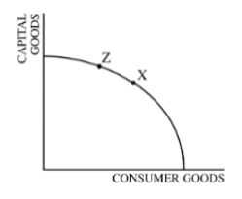b 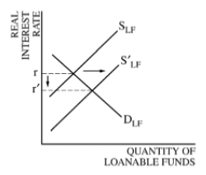c 1 point is earned for: showing point Z to the left of point X on the curve.
D 1 point is earned for: stating that the long-run aggregate supply (LRAS) curve will shift to the right and for explaining that capital accumulation will increase.
2a 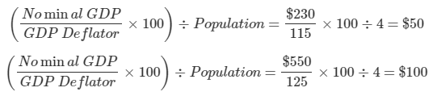
B The response states that Southland has the higher money supply in Year 2 and explains that using the quantity theory of money ( MV=PY ), since the two nations have the same velocity of money and Southland has a higher nominal GDP in Year 2, Southland has the higher money supply.
C The response calculates the inflation rate in Eastland in Year 2 as 15%, calculates the inflation rate in Southland in Year 2 as 25%, and shows the work.
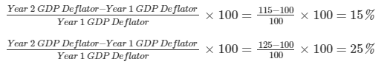
D The response states that Eastland experienced the higher real interest rate and explains that Eastland had lower inflation and the real interest rate is equal to the nominal interest rate minus the inflation rate.
e The response states that the long-run economic growth rate will increase in Southland and explains that by allocating fewer resources to the production of consumer goods, capital formation will increase, leading to greater future production and consumption.

